Learn Laravel framework –MVC

Laravel router

MVC – Controller: Act as an organization between different layers to control the flow of the application. It handles events and responds to them. "Events" include the user's behavior and changes to the data Model

Router test:

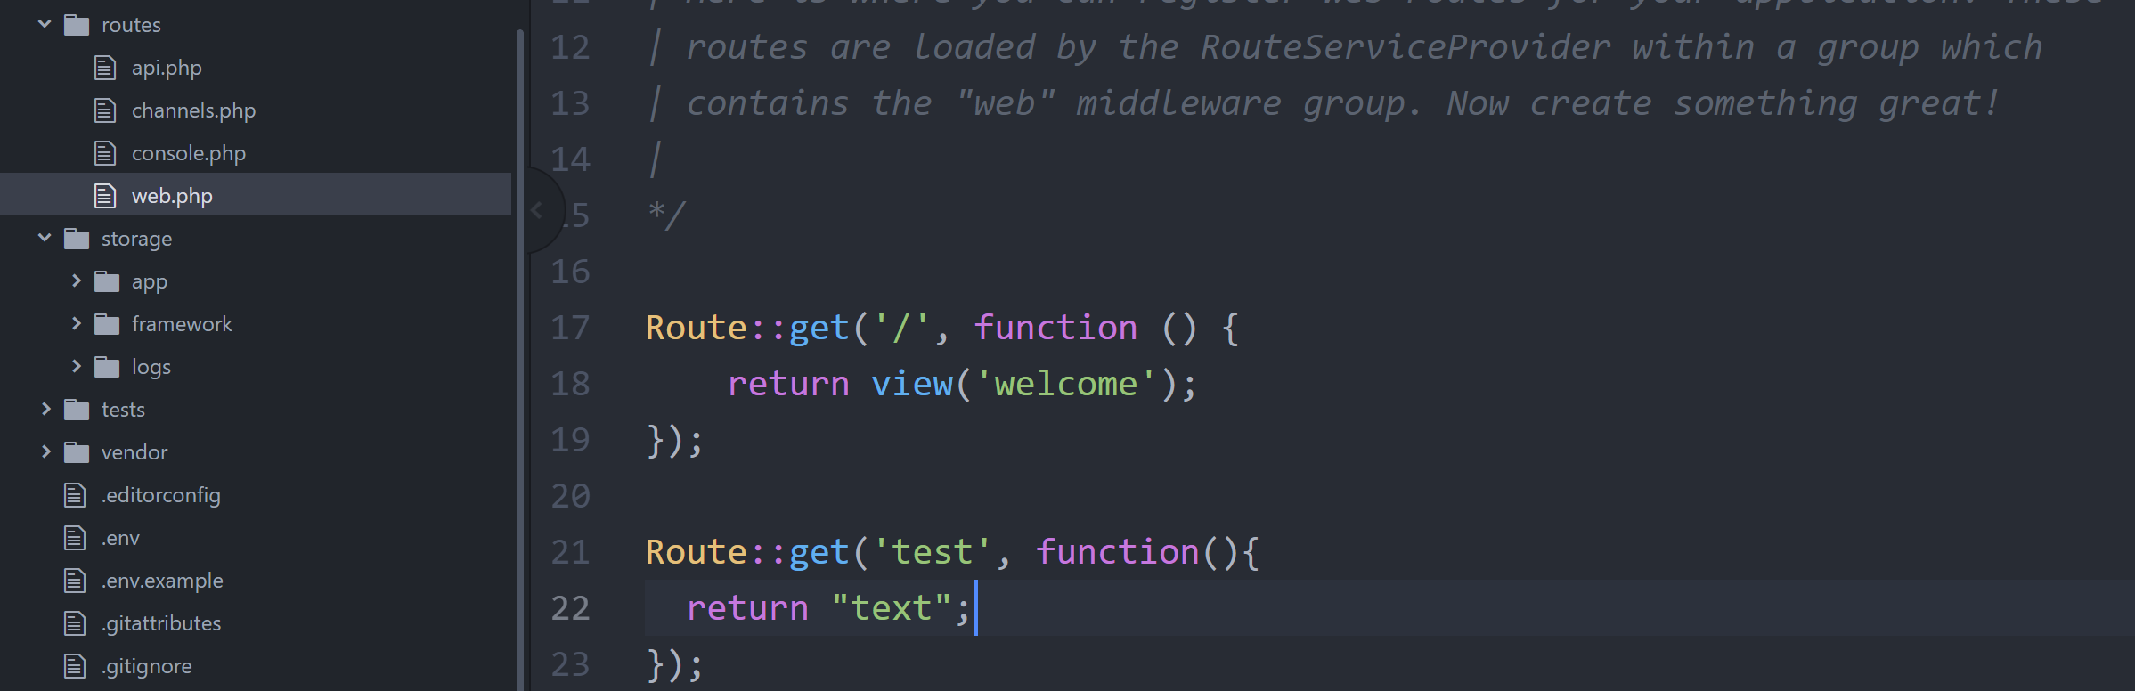

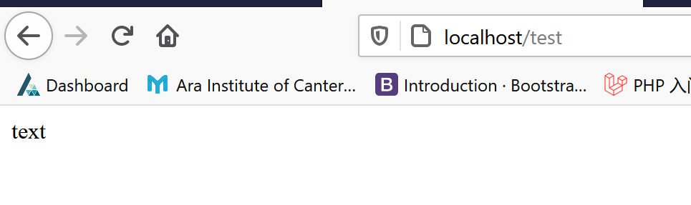

Use Controller to control View:

Create a new controller



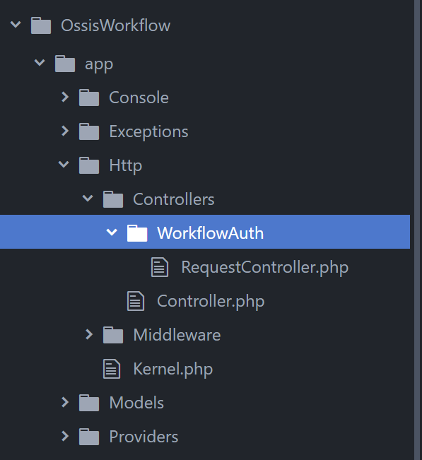

Write function in Controller:

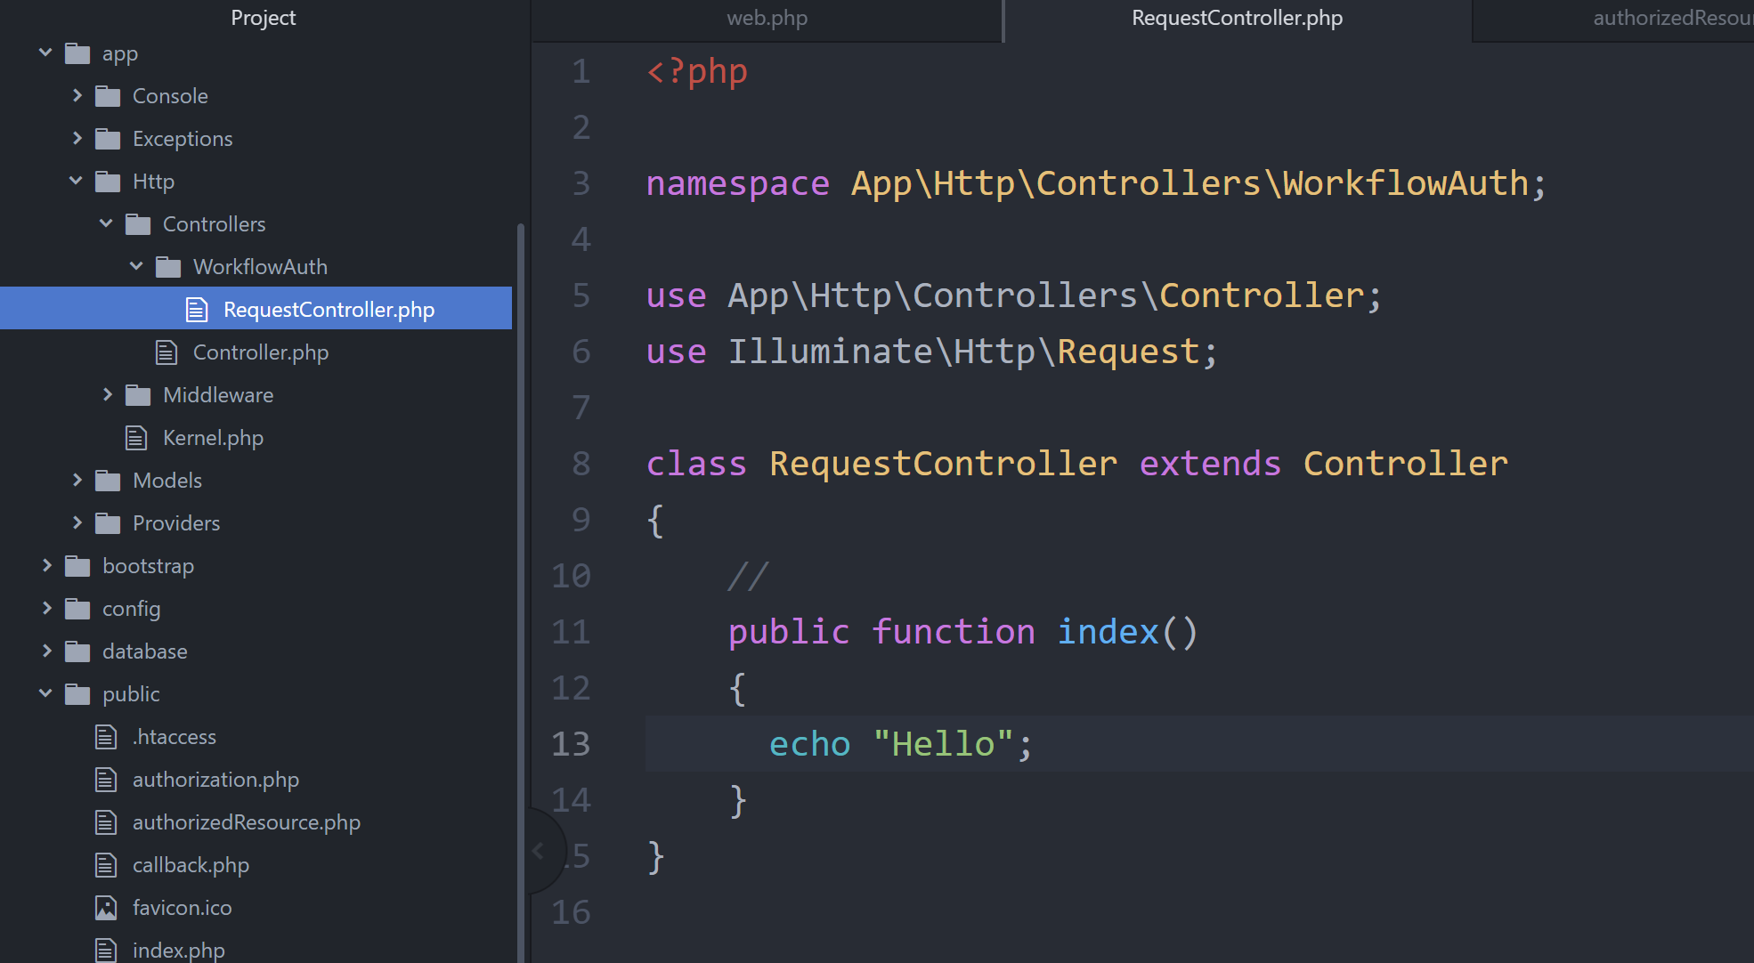

Link router to this Controller:

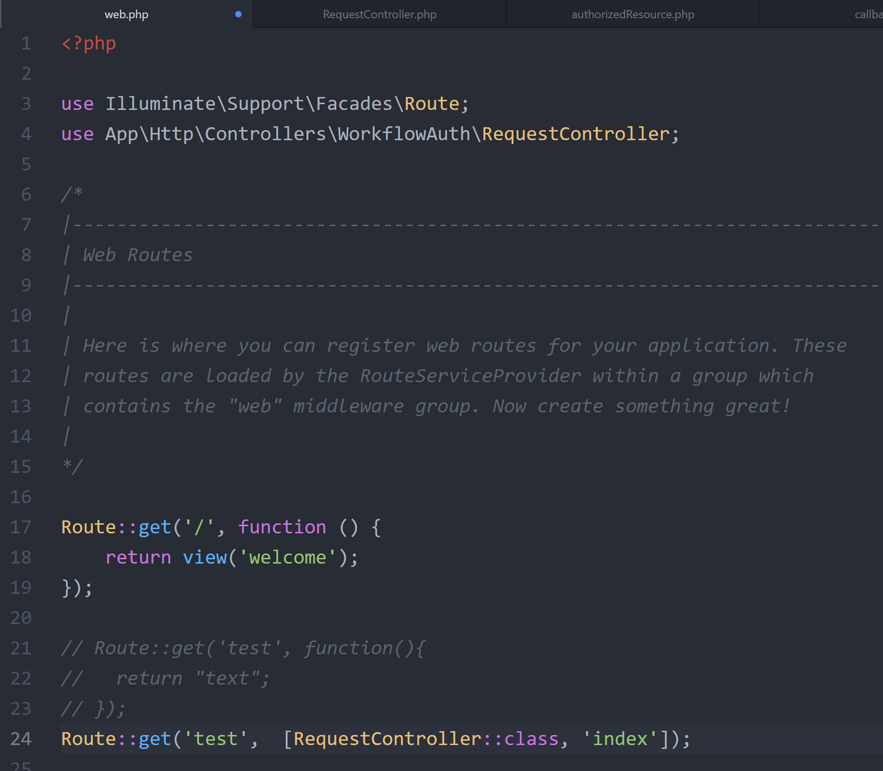

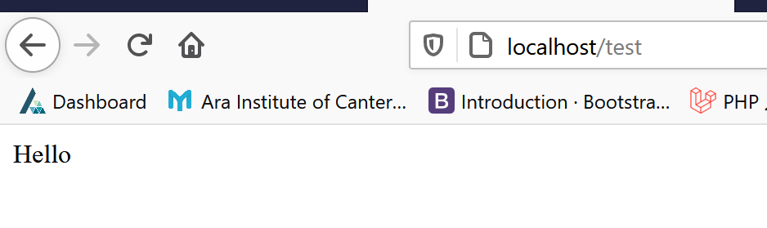

Send requests to Workflow Max from this Controller:

In callback.php, header to router (test)

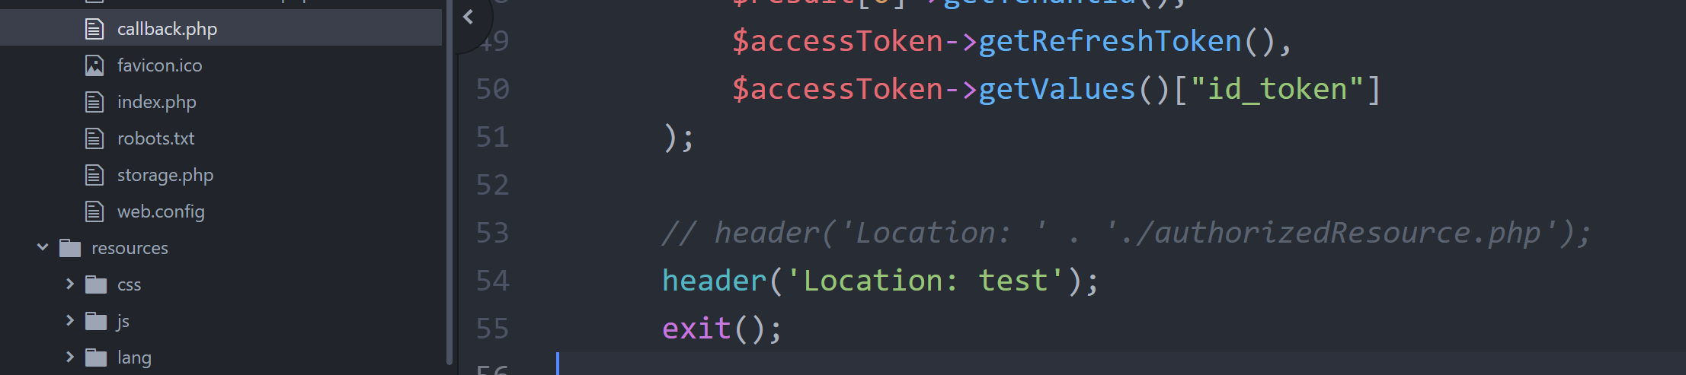

Try to make the first request.

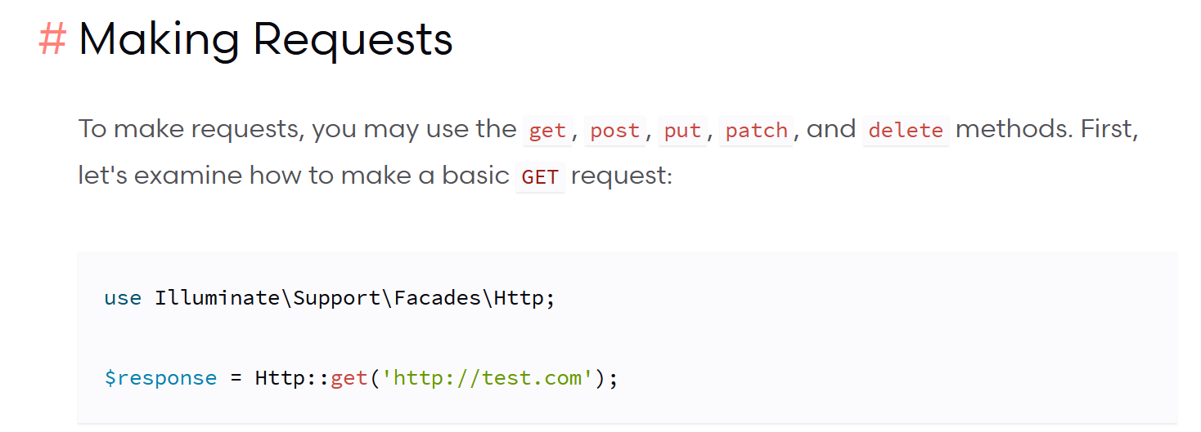

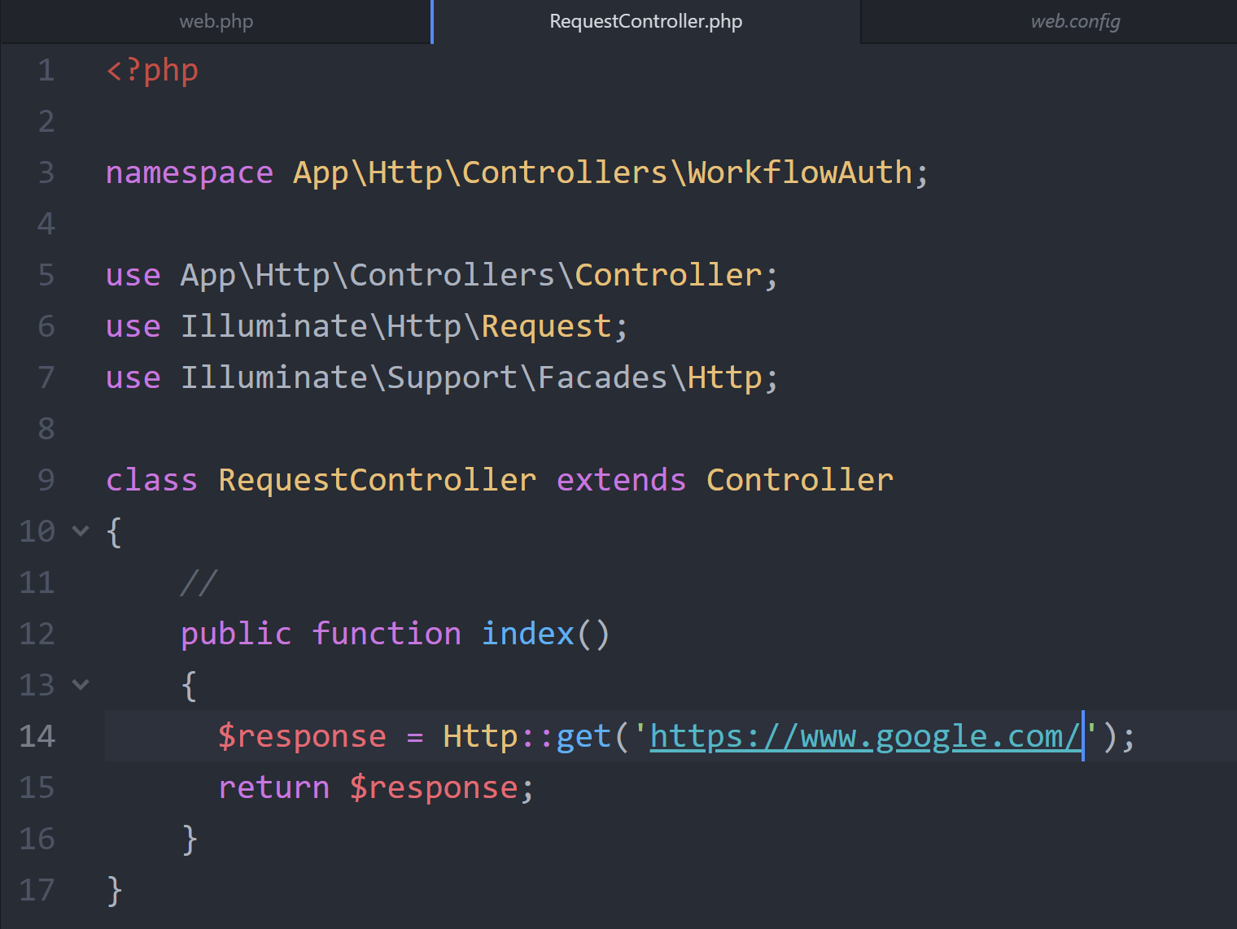

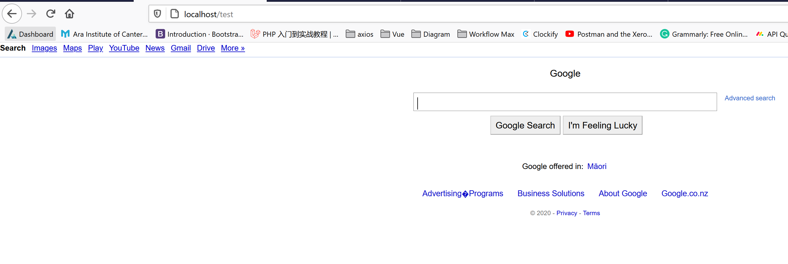

Think about how to get the token from Workflow Max….

Last week, I use callback.php to show the token, then…

1. How this Controller get the Workflow Max Token.

ERROR1:

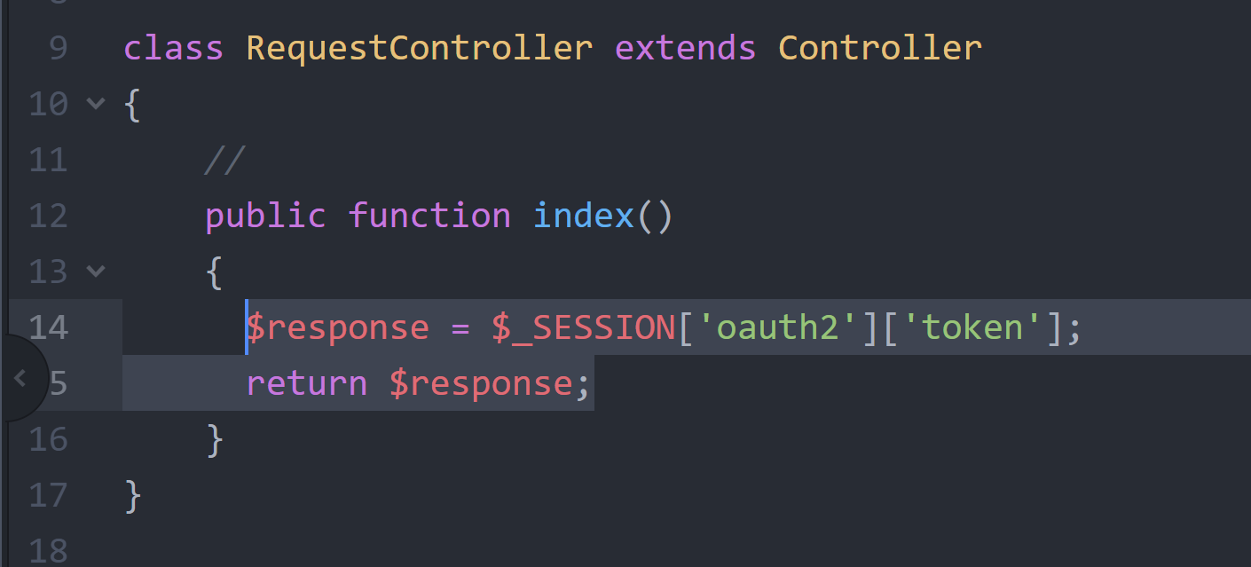

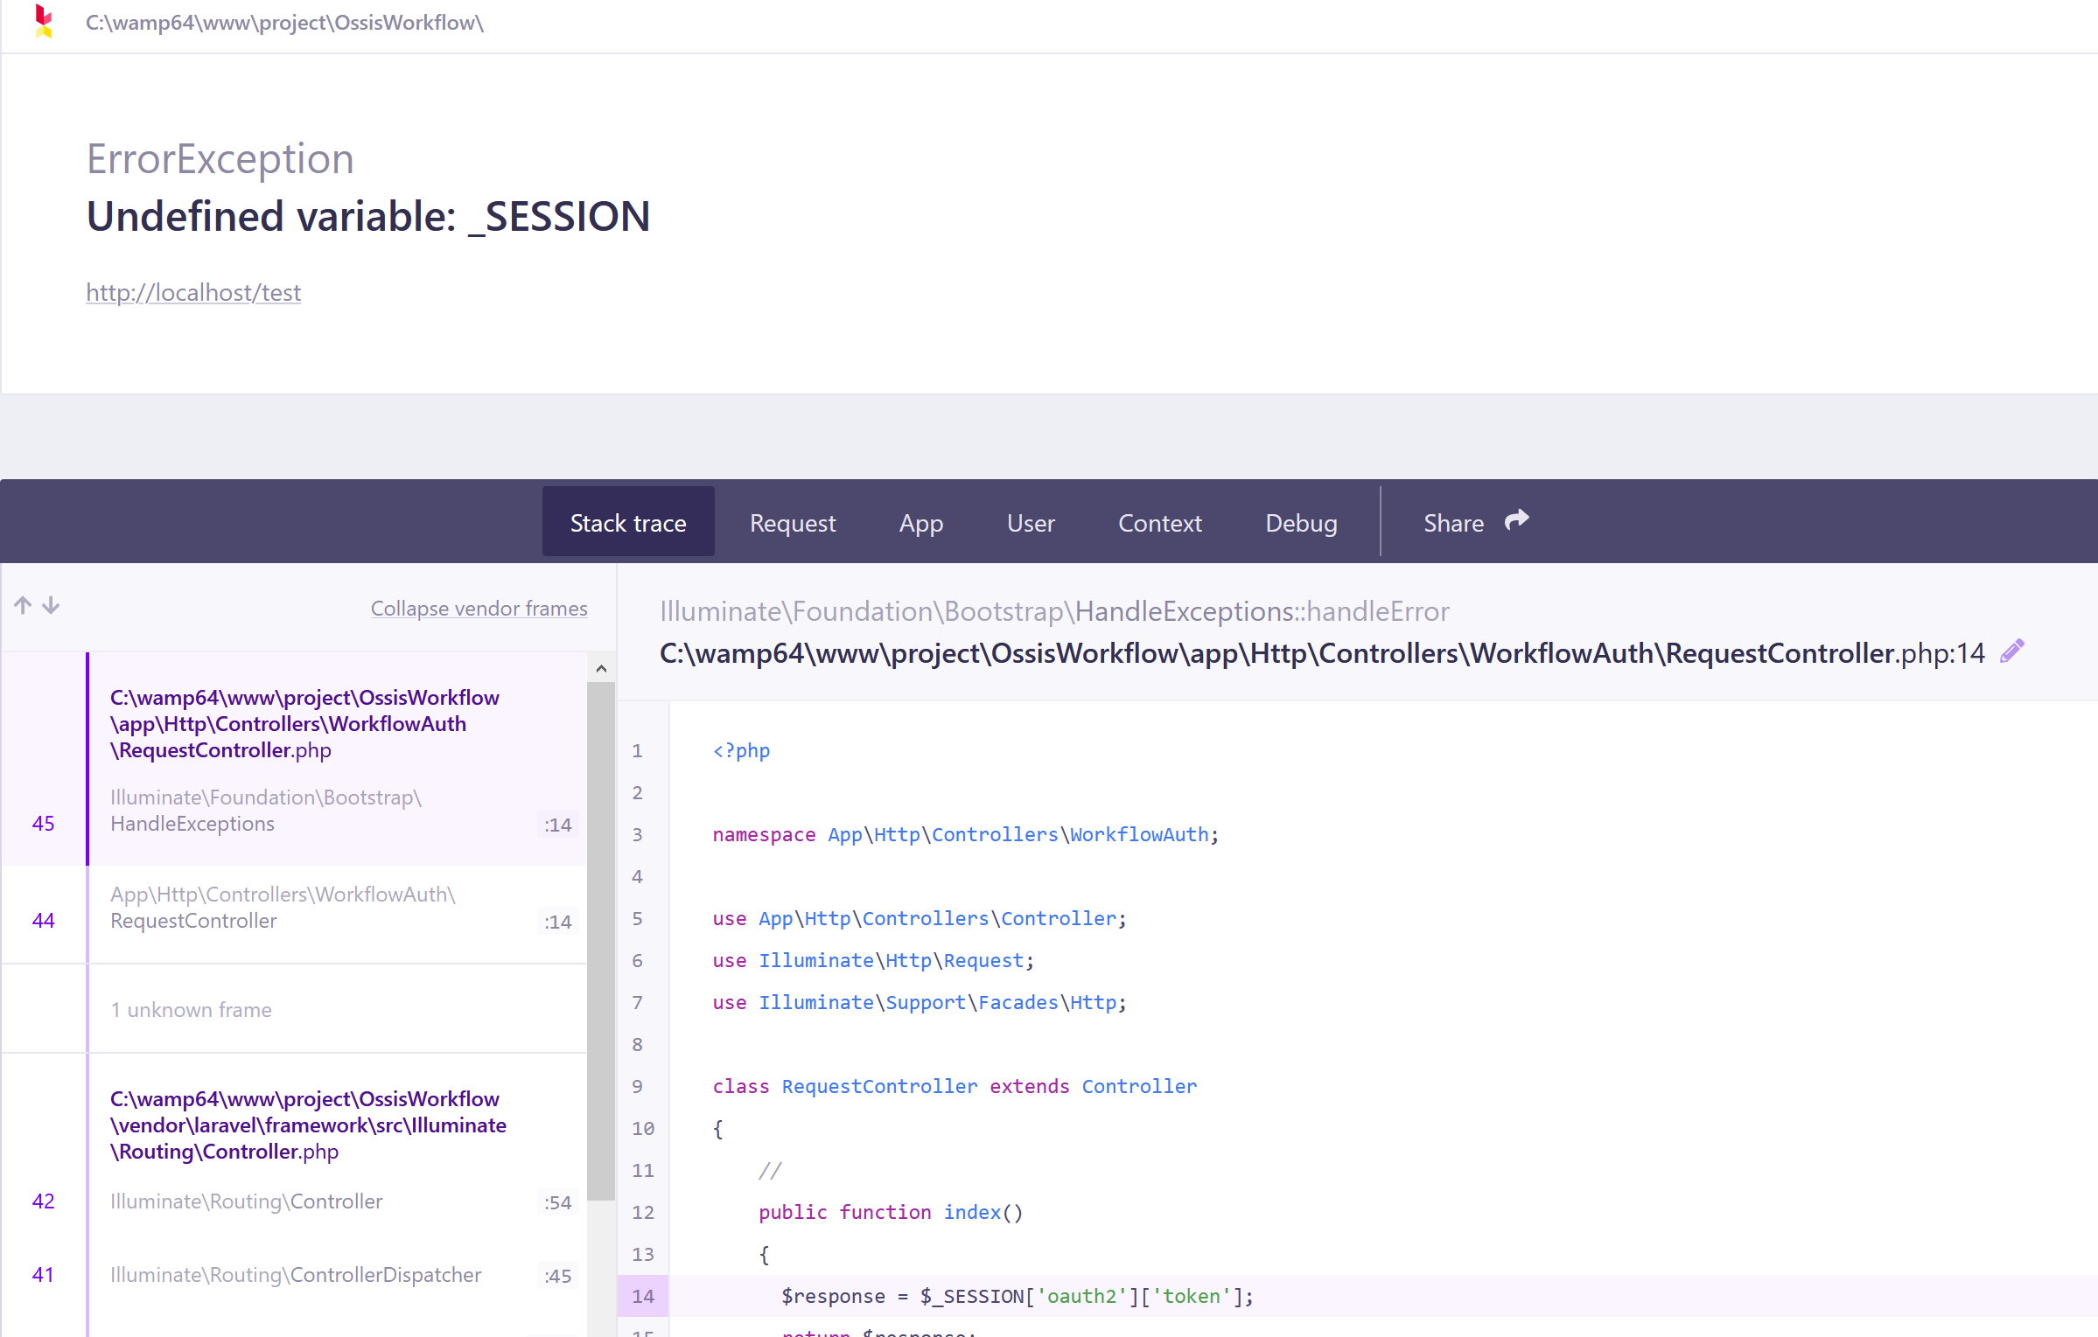

Google:

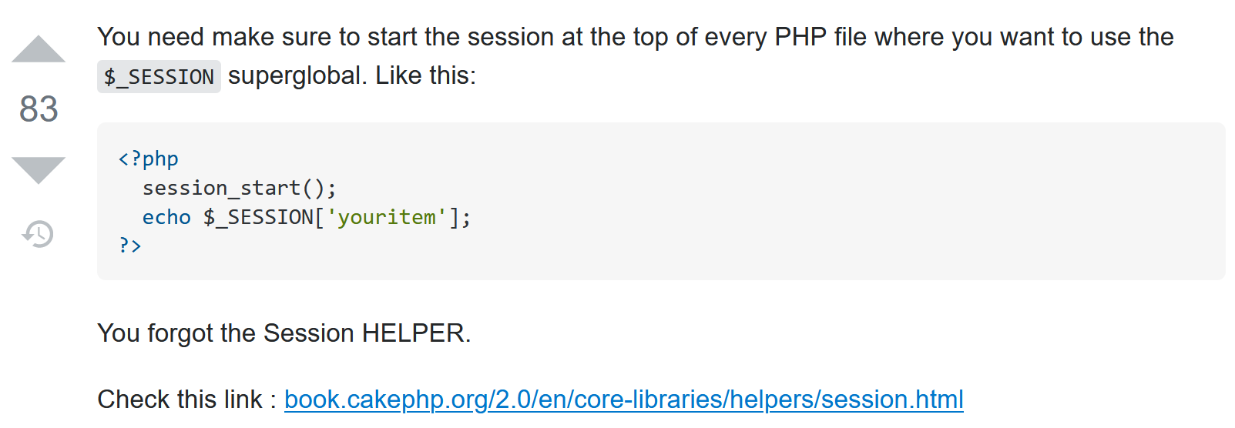

Fixed:

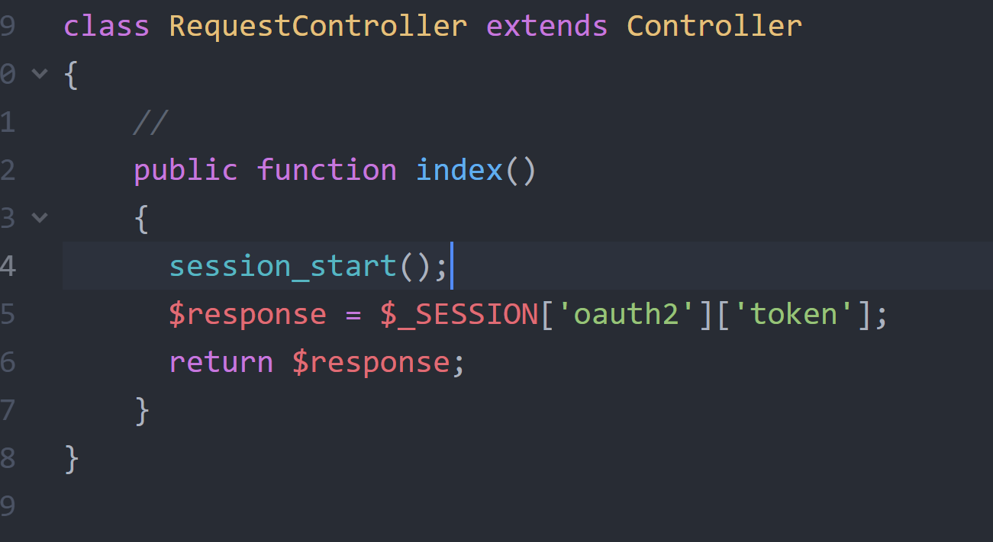

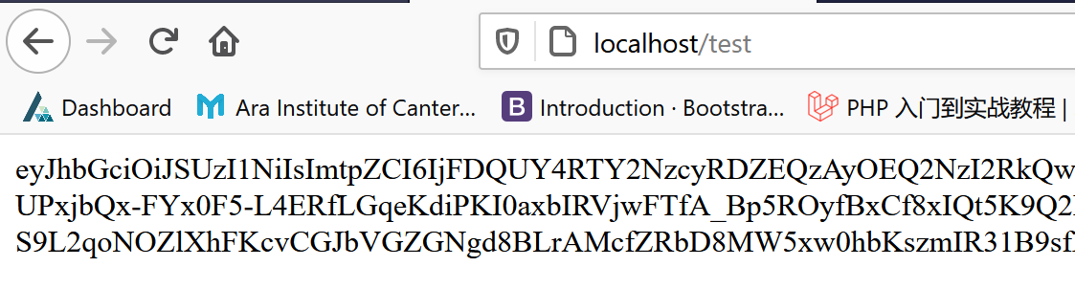

How to send request to Workflow Max with token:

When we send request on Postman:

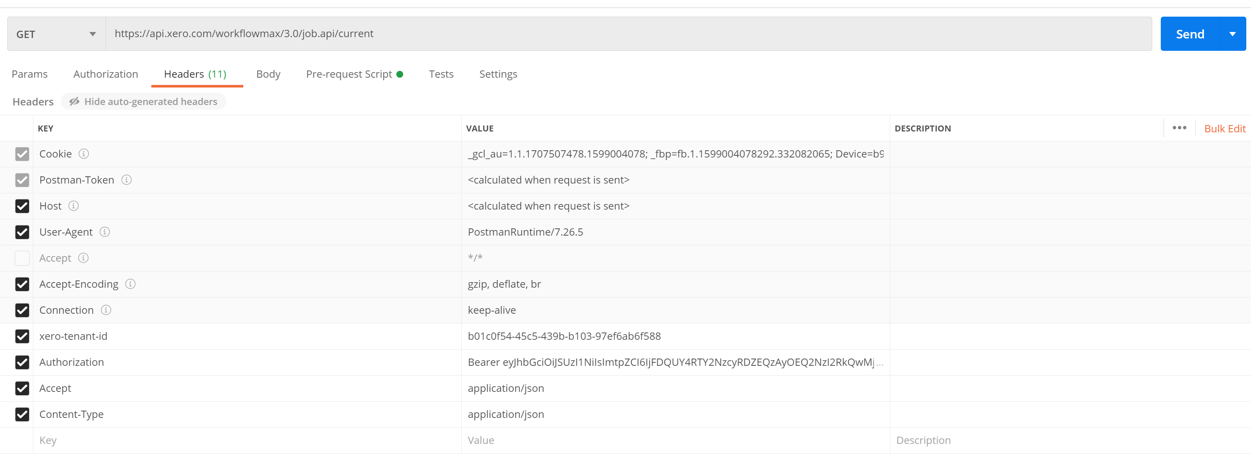

So I search the method from <https://laravel.com/docs/8.x/http-client>

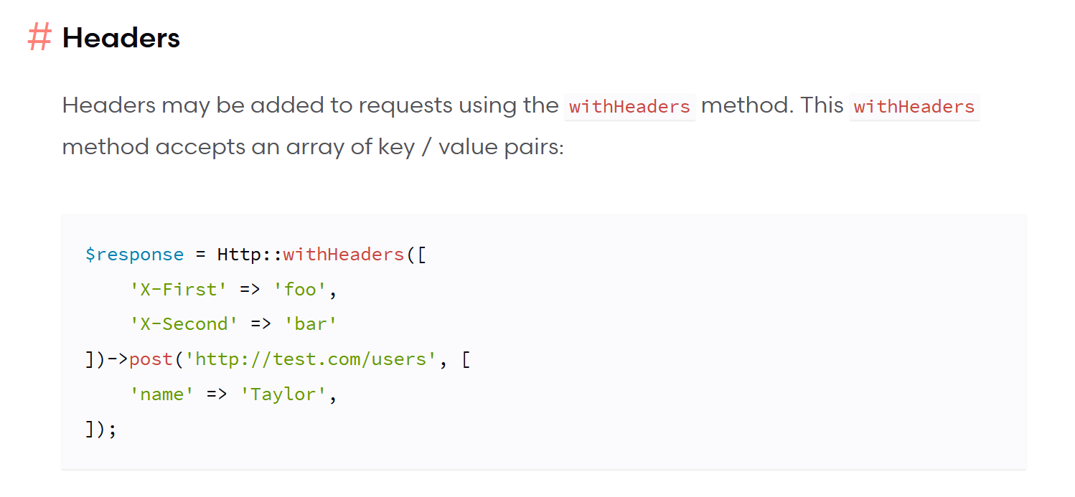

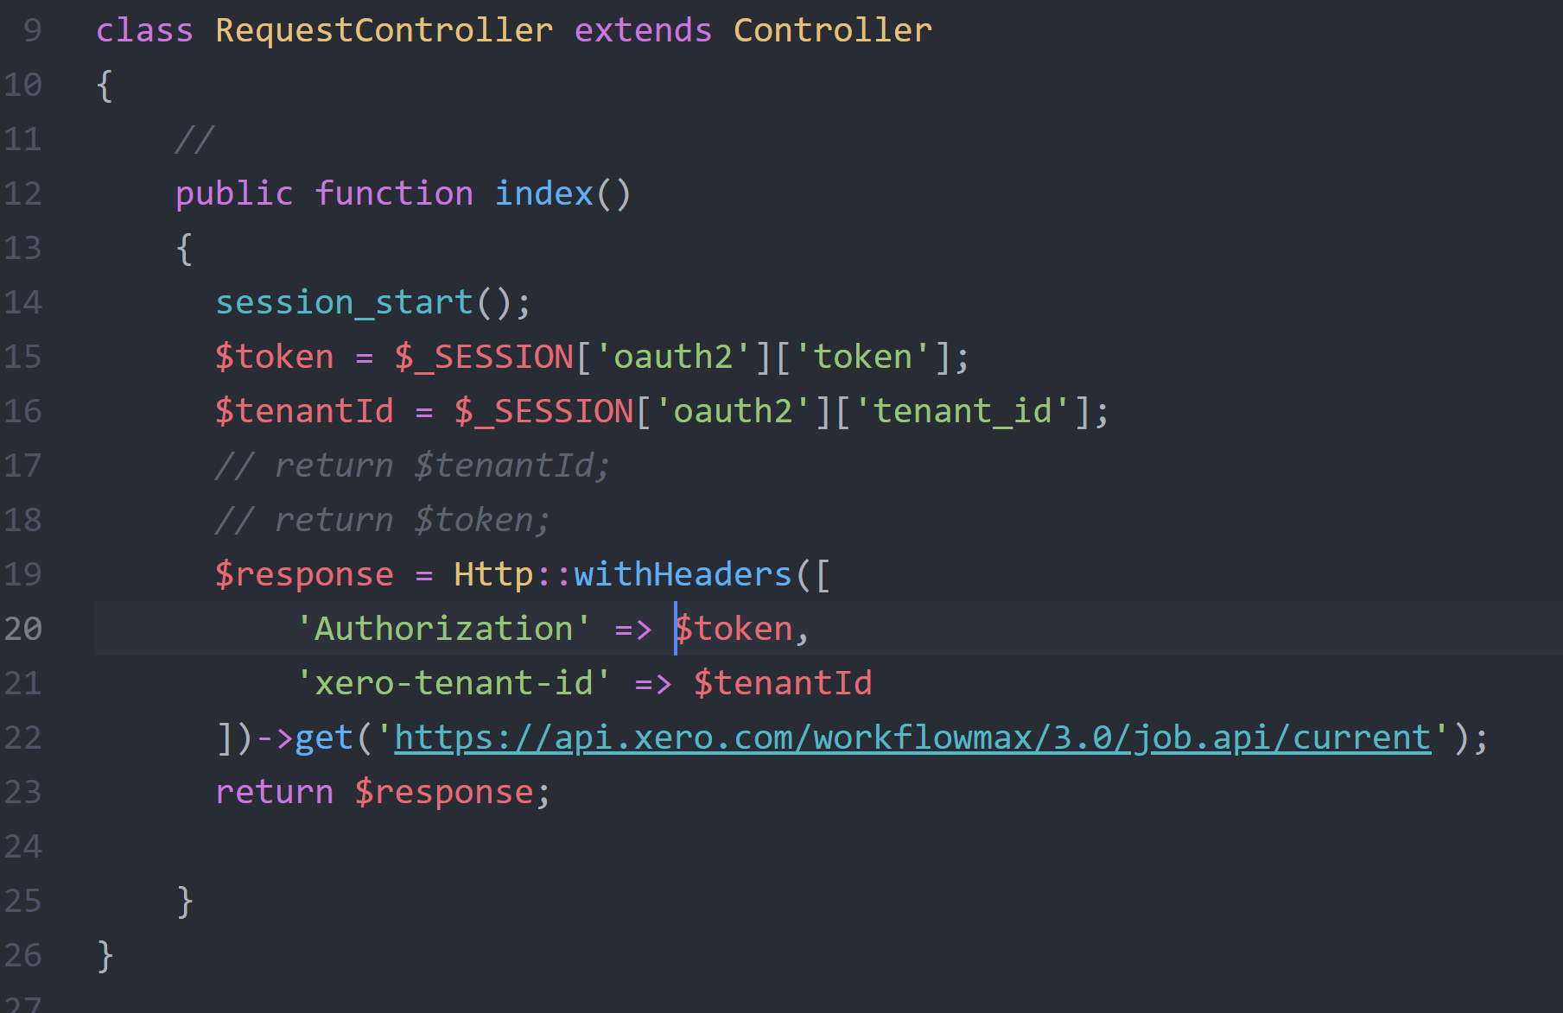

Error :

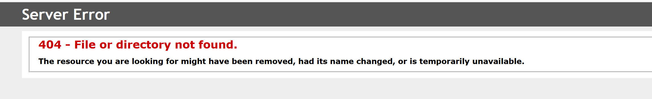

Compare with Postman:

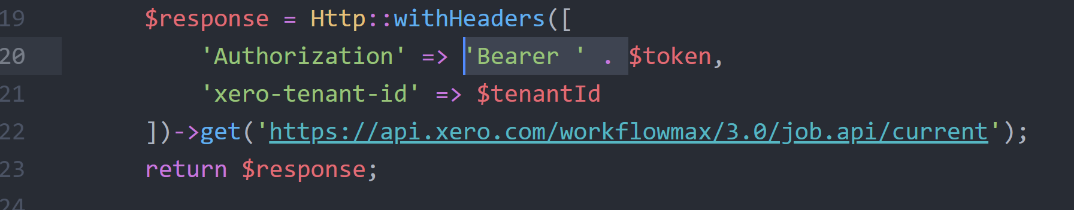

Successes:

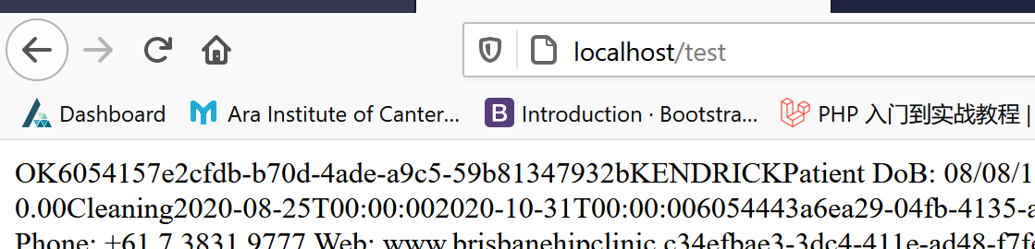

Next Step:

1. Hide ‘clientId’ and ‘clientSecret’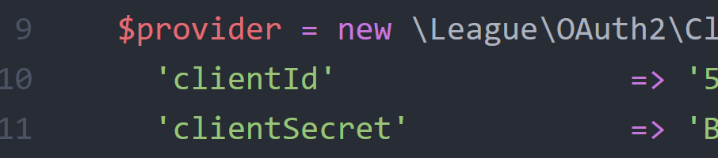
2. Translate XML format to JSON format
3. Get the data need to sync.
4. Consider how to callback to front-end.

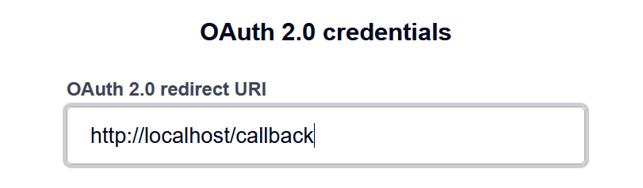should not have .php at the end.

So I need create a route redirect to callback page.

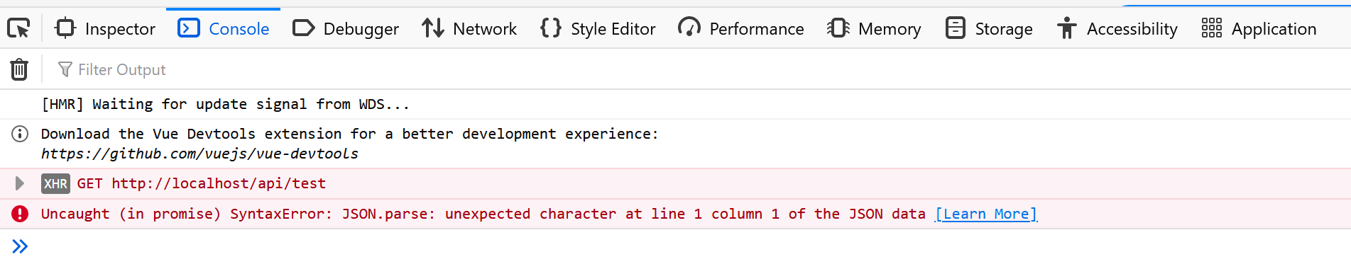

Get Start Page get token, redirect to Main page, then we lost token. Because the **session** is different from the one when we send token request.

